**Data Flow Diagram:**

Project Design Phase-II

Data Flow Diagram & User Stories

|  |  |
| --- | --- |
| Date | 03-11-2022 |
| Team ID | PNT2022TMID26825 |
| Project Name | Project - Real time River water quality monitoring and control system |

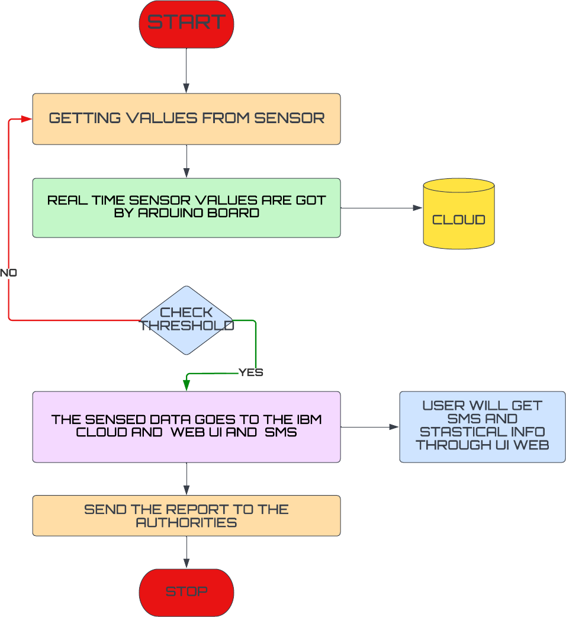

**User Stories**

|  |  |  |  |  |  |  |
| --- | --- | --- | --- | --- | --- | --- |
| **User Type** | **Functional Requirement (Epic)** | **User Story Number** | **User Story / Task** | **Acceptance criteria** | **Priority** | **Release** |
| Customer (Mobile user) | Registration | USN-1 | As a user, I can register for the application by  entering email, password, and confirming my password. | I can access my account/dashboard | High | Sprint-1 |
|  |  | USN-2 | As a user, I will receive a confirmation  email once I have registered for the application | I can receive e  confirmation email & click confirm | High | Sprint-2 |
|  |  | USN-3 | As a user, I can register for the application through Google | I can register & access the dashboard with Google | High | Sprint-1 |
|  |  | USN-4 | As a user, I can register for the application through Gmail | I can register through the mail. | Medium | Sprint-2 |
|  | Login | USN-5 | As a user, I can log into the application by entering email, password & captcha | I can receive login credentials. | High | Sprint-1 |
|  | Interface | USN-6 | As a user, the interface should be user-friendly manner | I can able to access easily. | Medium | Sprint-1 |
| Customer (Web user) | dashboard | USN-7 | As a user, I can access the specific info(ph value, temp, humidity, quality). | I can able to know the quality of the water. | High | Sprint-1 |
| Customer (input) | View manner | USN-8 | As a user, I can view data in visual representation manner(graph) | I can easily understand by visuals. | High | Sprint-1 |
|  | Taste | USN-9 | As a user , I can able to view the quality(salty) of the water | I can easily know whether it is salty or not . | High | Sprint-1 |
|  | Color visibility | USN-10 | As a user , I can able predict the water color | I can easily know the condition by color. | High | Sprint-1 |
| Administrator | Risk tolerant | USN-11 | An administrator who Is handling the system should update and take care of the application. | Admin should monitor the records properly. | Medium | Sprint-2 |